PROJECT DOCUMENTATION
Construction Intelligence Hub
A Centralized Platform for Construction Project Management

Milestone 2 Report
Frontend User Interface Development using Python and Streamlit

Submitted by
PRIYADHARSHINI S

COMPUTER SCIENCE AND ENGINEERING
PANIMALAR ENGINEERING COLLEGE
FINAL YEAR

CERTIFICATE
This is to certify that the project titled “Construction Intelligence Hub” has been successfully carried out by PRIYADHARSHINI S, as part of the requirements for COMPUTER SCIENCE AND ENGINEERING in PANIMALAR ENGINEERING COLLEGE during the academic year FINAL YEAR under the guidance and supervision of the undersigned.

This report is a record of the work carried out by the student(s) for Milestone 2 of the project and is submitted in partial fulfilment of the requirements of the course.
Date: ___________________
Place: ___________________

Signature of Project Guide
[Guide Name & Designation]

ACKNOWLEDGEMENT
We would like to express our sincere gratitude to our project guide, [Guide Name], for the valuable guidance, encouragement, and support extended throughout the development of this project.
We are also thankful to the Department of COMPUTER SCIENCE AND ENGINNERING in PANIMALAR ENGINEERING COLLEGE for providing the necessary resources and environment to carry out this work.
Finally, we extend our heartfelt thanks to our family and friends for their constant support and motivation throughout this project.

CONSTRUCTION INTELLIGENCE HUB

Abstract
Construction Intelligence Hub is a centralized platform designed to streamline the management of construction projects. The application addresses common challenges faced in the construction industry such as manual record keeping, fragmented information, and poor communication between project stakeholders. Milestone 1 of this project focuses on building the frontend user interface using Python and Streamlit, providing an intuitive dashboard for project registration, progress tracking, material management, and safety compliance. Future milestones will extend the system with database connectivity, analytics, and AI-based decision support.

1. Introduction
Construction projects are inherently complex, involving multiple stakeholders, resources, schedules, and safety requirements that must be coordinated effectively. The Construction Intelligence Hub project aims to provide a centralized platform for managing construction projects, tracking progress, monitoring resources, and improving communication among project teams.
In Milestone 2, the frontend user interface of the application has been developed using Python and Streamlit, which allows for rapid development of interactive, data-driven web applications. This milestone lays the foundation for a fully functional project management system that will be enhanced with backend and analytical capabilities in subsequent milestones.

2. Problem Statement
Construction projects often face several recurring challenges that reduce efficiency and increase costs, including:
- Manual record management leading to errors and delays
- Difficulty tracking project progress in real time
- Material wastage due to lack of visibility into resource availability
- Lack of a centralized source of project information
- Poor communication between teams and stakeholders
The Construction Intelligence Hub aims to solve these problems by bringing all relevant project information together in a single, easy-to-use dashboard

3. Objectives
The key objectives of this project are:
- Manage construction project information in a structured manner
- Monitor project progress through an intuitive interface
- Manage workforce details for each project
- Track material availability and requirements
- Improve overall project planning and coordination
- Provide a simple and user-friendly interface for all stakeholders

4. Scope
The scope of Milestone 2 is limited to the design and development of a functional frontend interface that demonstrates the core features of the platform using sample data. This includes project registration, progress tracking, material selection, a safety checklist, and site updates. Database integration, user authentication, analytics, and AI-driven features are outside the scope of this milestone and are planned for future development phases.

5. System Architecture
The current architecture (Milestone 2) consists of a single-tier Streamlit frontend application that collects user input through forms and displays the submitted information back to the user. Database integration is planned for later milestones.
User
↓
Construction Intelligence Hub
(Streamlit Frontend UI)
↓
User Inputs (Forms)
↓
Display Submitted Information
(Database integration in later milestones)

6. Technologies Used
Technology | Purpose
Python | Programming Language
Streamlit | Frontend UI Development
IDLE Python | Code Editor
Ollama (llama3) | Local LLM engine powering the AI Chatbot module

7. Proposed System
The proposed Construction Intelligence Hub is envisioned as a comprehensive, data-driven platform that goes beyond the current milestone's frontend prototype. The system will provide role-based access for project managers, workers, and administrators, and will integrate real-time data such as weather and material deliveries to support proactive project management.

8. UI Screenshots
This section showcases screenshots captured directly from the running Construction Intelligence Hub application (localhost:8501), covering the Dashboard, AI Chatbot (Ollama), Cost Prediction, Delay Risk Prediction, Safety & Compliance, CV Inspection, Project Task Management, Reports, and About pages.

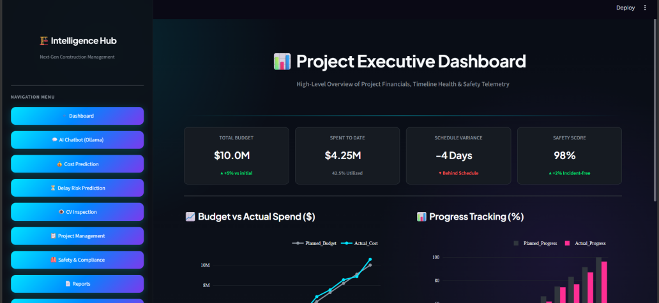

Figure 8.1 – Executive Dashboard

Definition: The Dashboard is the landing screen of the application. It gives a real-time, portfolio-wide summary of all active construction sites, combining key metric cards with charts.
Explanation: Four metric cards summarize the portfolio: Total Budget ($10.0M, +5% vs initial), Spent to Date ($4.25M, 42.5% utilized), Schedule Variance (−4 Days, behind schedule), and Safety Score (98%, +2% incident-free). Below them, a line chart tracks Planned Budget against Actual Cost by month, and a grouped bar chart tracks Planned Progress against Actual Progress (%) by month.

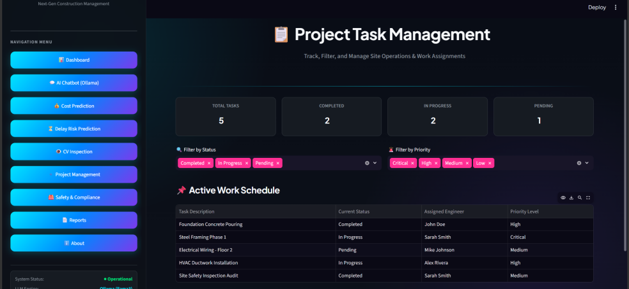

Figure 8.2 – Project Task Management

Definition: The Project Task Management page tracks, filters, and manages site-level work assignments across the project.
Explanation: Summary cards show Total Tasks, Completed, In Progress, and Pending counts. Filter chips let the user narrow the list by Status (Completed, In Progress, Pending) and Priority (Critical, High, Medium, Low), and an Active Work Schedule table lists each task's description, current status, assigned engineer, and priority level.
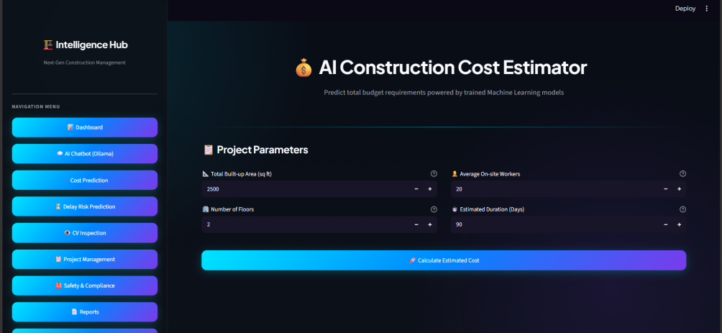

Figure 8.3 – Cost Prediction
Definition: The Cost Prediction page forecasts a project's final cost from a set of planning inputs.
Explanation: Titled “AI Construction Cost Estimator” and subtitled “Predict total budget requirements powered by trained Machine Learning models,” the page presents a Project Parameters form where the user enters Total Built-up Area (sq ft), Average On-site Workers, Number of Floors, and Estimated Duration (Days) using stepper inputs, then selects “Calculate Estimated Cost” to generate the forecast.
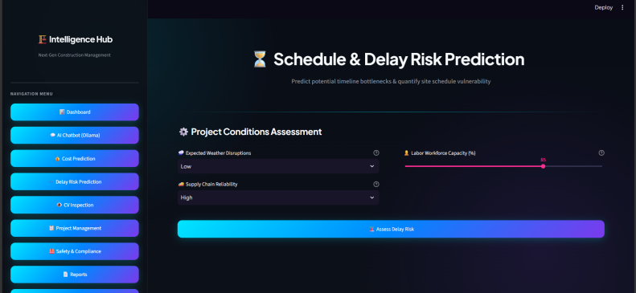

Figure 8.4 – Delay Risk

Definition: The Delay Risk page assesses the likelihood that a project's schedule will slip.
Explanation: Subtitled “Predict potential timeline bottlenecks & quantify site schedule vulnerability,” the Project Conditions Assessment form lets the user set Expected Weather Disruptions and Supply Chain Reliability from dropdowns (e.g. Low, High) and Labor Workforce Capacity (%) from a slider, then clicks Assess Delay Risk to generate the prediction.
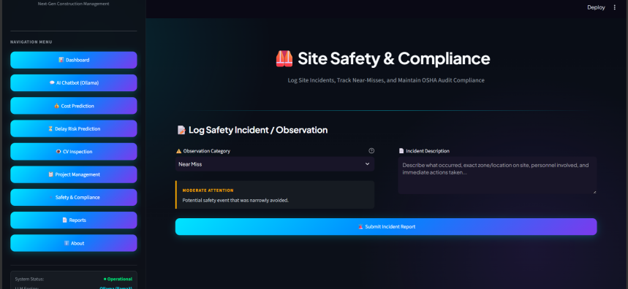
Figure 8.5 – Safety & Compliance
Definition: The Site Safety & Compliance page lets users log site incidents, track near-misses, and maintain OSHA audit compliance.
Explanation: In the “Log Safety Incident / Observation” form, the user selects an Observation Category (e.g. Near Miss), which surfaces a severity note (e.g. “Moderate Attention — Potential safety event that was narrowly avoided”), and enters a free-text Incident Description before selecting Submit Incident Report.

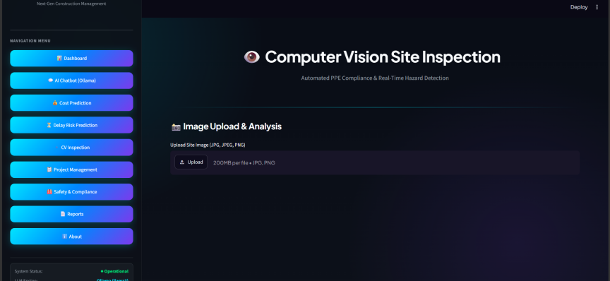

Figure 8.6 – CV Inspection

Definition: The Computer Vision Site Inspection page, subtitled “Automated PPE Compliance & Real-Time Hazard Detection,” lets a user upload a construction-site photo for automated visual analysis.
Explanation: An Image Upload & Analysis panel accepts a site image in JPG, JPEG, or PNG format up to 200MB per file. The sidebar footer confirms live System Status (Operational) and the active LLM Engine (Ollama, llama3) used elsewhere in the platform.
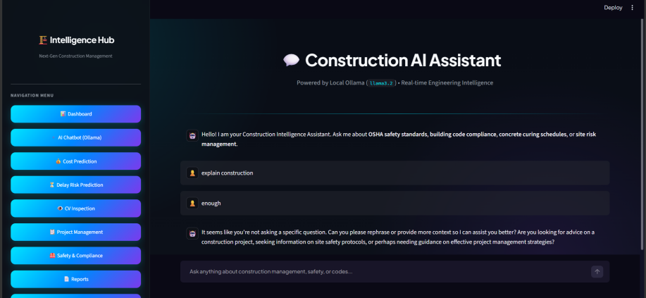
Figure 8.7 – AI Chatbot (Ollama)
Definition: The Construction AI Assistant is a chatbot, powered by a local Ollama model, that answers construction-related questions in natural language.
Explanation: The header confirms the assistant is “Powered by Local Ollama (llama3.2) • Real-time Engineering Intelligence.” The assistant opens with a greeting inviting questions on OSHA safety standards, building code compliance, concrete curing schedules, or site risk management. Responses stream token-by-token from the local model into the chat window, and a text box at the bottom accepts free-form questions about construction management, safety, or codes.

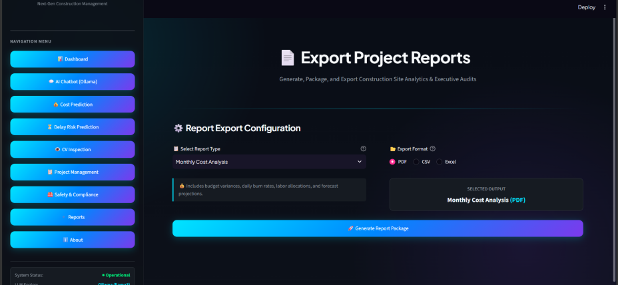
Figure 8.8 – Export Project Reports

Definition: The Export Project Reports page generates, packages, and exports construction site analytics and executive audits.
Explanation: The user selects a Report Type from a dropdown (e.g. Monthly Cost Analysis, which includes budget variances, daily burn rates, labor allocations, and forecast projections) and an Export Format (PDF, CSV, or Excel). A Selected Output summary confirms the chosen report and format before the user clicks Generate Report Package.
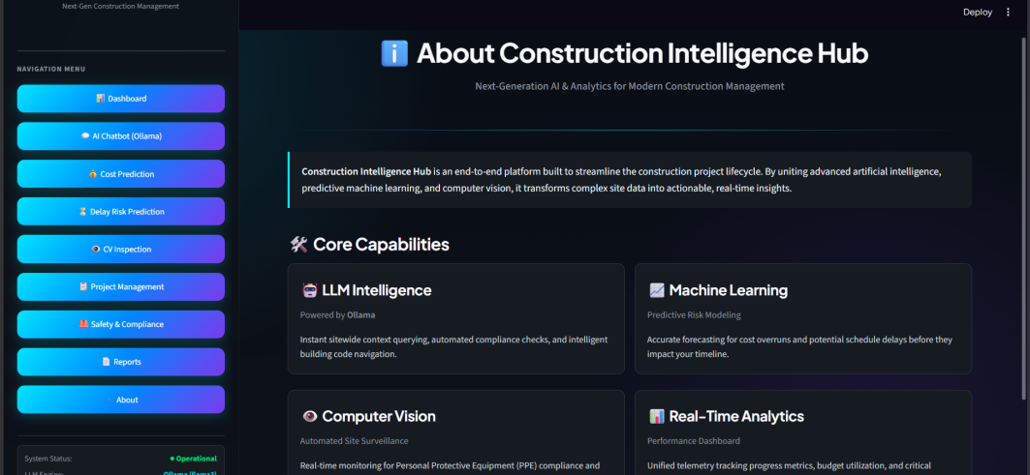

Figure 8.9 – About This Project

Definition: The About page describes the overall system architecture and the technologies used to build the application.
Explanation: Subtitled “Next-Generation AI & Analytics for Modern Construction Management,” the page opens with a summary of the platform, then lists four Core Capabilities in cards: LLM Intelligence (powered by Ollama – instant sitewide context querying, automated compliance checks, and intelligent building code navigation), Machine Learning (predictive risk modeling – accurate forecasting for cost overruns and potential schedule delays), Computer Vision (automated site surveillance – real-time PPE compliance and active hazard detection), and Real-Time Analytics (performance dashboard – unified telemetry tracking progress, budget, and project health indicators).

9. Module Description
The application is organized into the following modules:

Module | Description
Dashboard | Shows a real-time, portfolio-wide summary with metric cards and charts.
Project Task Management | Tracks, filters, and manages site operations and work assignments across tasks.
Cost Prediction | Forecasts a project's final cost from planning inputs such as budget, duration, and site complexity.
Delay Risk | Assesses the likelihood of schedule slippage for a project based on its risk factors.
Safety & Compliance | Logs site incidents and near-misses and helps maintain OSHA audit compliance.
CV Inspection | Analyzes an uploaded site photo for automated PPE compliance and hazard detection.
AI Chatbot (Ollama) | A chatbot, powered by a local Ollama model, that answers construction-related questions.
Reports | Generates and exports project analytics reports in PDF, CSV, or Excel format.
About | Describes the system architecture, technologies used, and key capabilities.

9.1 Dashboard
The Dashboard is the landing page of the application. It provides a real-time overview of the entire project portfolio through metric cards (Total Projects, Active Sites, On-Time percentage, Portfolio Value, Safety Score) and charts comparing budget vs. actual cost and project status distribution.

9.2 Project Task Management
This section summarizes total, completed, in-progress, and pending tasks, allows users to filter the work schedule by Status and Priority, and displays each task's description, current status, assigned engineer, and priority level in a searchable table.

9.3 Cost Prediction
Users can enter planning details for a new or existing project (budget, duration, workers, site complexity, and related factors) to receive an estimated final cost, along with a breakdown of the factors that most influence the estimate.

9.4 Delay Risk
This section allows users to enter project details and receive an assessment of the project's schedule delay risk, along with the key factors contributing to that risk.

9.5 Safety & Compliance
This section lets users log a safety incident or observation by selecting an Observation Category and entering an incident description, supporting ongoing OSHA audit compliance and near-miss tracking.

9.6 CV Inspection
This section allows users to upload a construction site photograph (JPG, JPEG, or PNG, up to 200MB) for automated PPE compliance and real-time hazard detection.

9.7 AI Chatbot (Ollama)
This section provides a chatbot interface, powered by a local Ollama (llama3.2) model, where users can ask free-form questions about construction management, safety standards, and building codes, with responses streamed back token-by-token.

9.8 Reports
This section lets users select a report type (such as Monthly Cost Analysis) and an export format (PDF, CSV, or Excel), then generate a packaged report of site analytics and executive audits.

9.9 About
This section describes the overall system architecture, the technologies used to build the application, and the key capabilities it demonstrates.

10. Future Enhancements
The following features are planned for future milestones:
- AI-based project delay prediction
- Material demand forecasting
- Equipment monitoring
- Live weather integration
- Worker attendance tracking
- Cost estimation
- Interactive dashboards
- Report generation
- Database connectivity
- Login system

11. Conclusion
Construction Intelligence Hub provides an easy and efficient way to manage construction projects. This milestone focuses on creating a user-friendly interface using Python and Streamlit, while future milestones will add database connectivity, analytics, and AI-based decision support to build a complete, production-ready project management solution.

12. REFERENCES
- Streamlit Documentation – https://docs.streamlit.io
- Python Software Foundation – https://www.python.org
- GitHub Documentation – https://docs.github.com

